**Quality Improvement Paper**

**Smoking Cessation in Heart Failure Patients**

Michael Boone, Jacqueline Danenhower, Marisa Flores,

Beeh Marie Otico, and Hannah Zonne

Samuel Merritt University

N466 Quality, Safety & Leadership III

Cinnamon R. Chavez**,** DNP, RN, CNL

April 6, 2025

**Problem Statement**

Patients with heart failure are at an increased risk for mortality and hospital readmission (Son & Lee, 2020). Smoking exacerbates the progression and severity of heart failure in patients. According to the Journal of the American College of Cardiology, smoking is a modifiable risk factor for heart failure (Ding et al., 2022).

**Background**

According to the Centers for Disease Control and Prevention (CDC), nearly 34 million adults in the United States smoke cigarettes (CDC, 2024). Studies have shown that smokers are 2-4 times more likely to develop heart failure compared to non-smokers (Johns Hopkins Medicine, n.d.). Approximately 6.2 million adults in the United States are currently living with heart failure (CDC, 2024). Persistent smoking in patients with heart failure worsens long-term outcomes and reduces the efficiency of heart failure treatment (Son & Lee, 2020). Not only is heart failure a burden on a patient's health, but it is also a substantial financial burden for patients and healthcare systems. The CDC estimates that heart failure costs the U.S. healthcare system more than $30 billion annually, considering medical costs and lost productivity (CDC, 2024). Self-management is critical for achieving the best patient outcomes and improving quality of life (Son & Lee, 2020).

**Identified Community & Stakeholders**

Smoking as a risk factor for heart failure significantly affects individual patients and the community. Key stakeholders, including patients, families, healthcare providers, insurers, and public health organizations, all have compelling reasons to prioritize solutions to this problem.

**Patients and Families**

The impact of smoking on patients with heart failure is profound, exacerbating the progression and severity of the condition. According to the American Heart Association (2024), smoking can contribute to a worsening of heart failure symptoms and increase healthcare needs, affecting both patients and their families. Families of patients with heart failure often bear emotional and financial burdens associated with caring for their loved ones with chronic health issues. These burdens can increase stress and decrease the quality of life for the patient and their family members.

**Healthcare Providers**

For healthcare providers, smoking complicates patient management and increases the risk of hospital readmissions. Smoking limits the effectiveness of treatments, including beta-blockers and ACE inhibitors, making it harder to stabilize heart failure patients. Additionally, smoking-related complications often necessitate more intensive care, increasing the burden on healthcare systems. A study published in the European Journal of Preventive Cardiology underscores these concerns, highlighting that smoking is a significant predictor of worse outcomes in heart failure patients, including higher mortality rates and frequent hospitalizations (Arnson et al., 2010).

**Insurers and Payers**

Individuals with heart failure who smoke tend to require more frequent hospitalizations and prolonged treatment periods and are at a higher risk of complications such as recurrent heart attacks. The necessity for more intensive treatments and monitoring inevitably leads to increased expenses, often surpassing those of non-smokers with heart failure. Furthermore, smoking-related heart failure progression may lead to an increase in disability claims and higher mortality rates, which further impacts insurance risk assessments and pricing models. Smoking significantly elevates healthcare costs in heart failure patients. This is attributed to higher rates of hospitalizations and more extended stays, contributing to an unsustainable surge in insurance expenses (Gheorghe et al., 2016).

**Community at Large**

Communities bear the impact of rising healthcare costs, decreased workforce productivity, and increased public health risks. Smokers with heart failure experience higher rates of hospitalization, placing a strain on local healthcare services and public resources. This results in a financial burden on communities, leading to higher taxes and insurance premiums to cover these expenses. Additionally, workforce productivity and increased reliance on social welfare programs are lost. A study published in The European Heart Journal emphasizes the broader societal costs of smoking-related cardiovascular diseases, demonstrating that smoking significantly contributes to higher healthcare expenditures and societal burden (Boehm et al., 2014).

**Literature Review of Evidence for Solutions**

Successful quality improvement projects hinge on the ability to track data, measure behaviors, and interpret results effectively (Butts-Dion et al., 2024). The initial systematic review by Wiggers et al. (2003) analyzed twelve randomized controlled trials (RCTs) investigating the efficacy of smoking cessation interventions in patients with cardiovascular disease (CVD), covering approximately 5,000 participants. This substantial sample size allowed for robust analysis, examining both short- and long-term impacts of smoking cessation on cardiovascular health. Spanning multiple years of data collection, the study synthesized findings across RCTs to assess the effectiveness of smoking cessation interventions specifically targeting patients diagnosed with symptomatic CVD. The methodology included multiple Cochrane reviews focused on secondary prevention strategies among different patient groups, enabling a comprehensive examination of intervention outcomes.

Key interventions analyzed included Nicotine Replacement Therapy (NRT), pharmacological aids, self-help materials, individual, group, and telephone counseling, as well as advice and counseling delivered by physicians and nurses. Each approach was compared against a placebo or standard care to evaluate its success in promoting smoking cessation. The review identified variability in intervention effectiveness, with five of the twelve studies reporting significant increases in cessation rates for the intervention group. However, the remaining studies indicated no significant effects from NRT, pharmacological aids, or counseling methods. This disparity underscored limitations in the overall effectiveness of these interventions in driving substantial smoking cessation outcomes among CVD patients (Wiggers et al., 2003).

The second study by Son and Lee (2020) conducted a comprehensive systematic literature review, utilizing databases such as PubMed, PsycINFO, Web of Science, and Embase. In addition to database searches, they employed hand searches to identify relevant studies, ensuring an exhaustive review process. The meta-analysis included nine studies: seven cohort studies and two cross-sectional studies. The quality of these studies was thoroughly evaluated using a modified version of the Newcastle–Ottawa Scale, which bolstered the reliability and validity of their conclusions.

Son and Lee's (2020) meta-analysis identified significant associations between persistent smoking and adverse health outcomes in patients with heart failure (HF). The findings revealed a 38.4% increase in mortality among persistent smokers, demonstrated by a hazard ratio (HR) of 1.384 (95% CI: 1.139–1.681). Moreover, persistent smokers faced a 44.8% higher readmission rate (HR = 1.448; 95% CI: 1.086–1.930) following a diagnosis of heart failure. Additional adverse outcomes linked to ongoing smoking included poorer overall health, increased occurrences of ventricular tachycardia, and greater arterial stiffness.

The study by Son and Lee (2020) highlights the urgent need for proactive smoking history assessments in HF patients. It stresses the importance of integrating smoking cessation programs into heart failure management. By tackling smoking behaviors, healthcare providers can potentially improve the prognosis and quality of life for these patients. Son and Lee (2020) also advocate for further research into the mechanisms through which smoking exacerbates health outcomes in heart failure patients, emphasizing the critical role of effective intervention strategies.

The third study by Ding et al. (2022) aimed to investigate the prospective associations between cigarette smoking, smoking cessation, and the incidence of heart failure, with a particular focus on heart failure with preserved ejection fraction (HFpEF) and heart failure with reduced ejection fraction (HFrEF). Data for this analysis was drawn from the Atherosclerosis Risk in Communities (ARIC) study, a well-established cohort that examines cardiovascular risk factors. A total of 9,345 participants, aged 61 to 81 years at baseline, were included in the analysis. The study utilized multivariable Cox proportional hazards models to evaluate the associations between smoking and the incidence of acute decompensated heart failure, which was adjudicated by physicians.

Over a median follow-up period of 13 years, 1,215 new cases of heart failure were documented. A key finding of the study was that although smoking cessation reduced the risk of heart failure, the elevated risks persisted for decades after cessation for both HFpEF and HFrEF. Former smokers exhibited a lower risk than current smokers but still faced a higher risk compared to individuals who had never smoked. These findings underscore that all measured aspects of smoking—current smoking, former smoking, and cumulative exposure—were significantly associated with both HFpEF and HFrEF. The persistent risk among former smokers points to the importance of long-term support and monitoring for individuals who quit smoking, emphasizing smoking as a critical modifiable risk factor for heart failure.

The fourth study by Kamimura et al. (2018) explored the relationship between cigarette smoking, left ventricular (LV) structure and function, and the incidence of heart failure (HF) hospitalizations in black adults. This research involved 4,129 participants with a mean age of 54 years, 63% of whom were women, and none had prior HF or coronary heart disease (CHD) at baseline. Participants were divided into three categories based on smoking status: never smokers (n = 2,884), current smokers (n = 503), and former smokers (n = 742). Cardiac magnetic resonance imaging (CMR) assessed LV structure and function for 1,092 participants, while brain natriuretic peptide (BNP) levels were measured in 3,325 participants. Over a median follow-up period of eight years, 147 participants experienced HF hospitalizations.

The results by Kamimura et al. (2018) indicated that current smokers had a higher mean LV mass index and lower LV circumferential strain compared to never smokers, both statistically significant with p-values less than 0.05. Additionally, smoking intensity and cumulative exposure (i.e., pack-years) were positively associated with elevated BNP levels. The hazard ratio (HR) for HF hospitalization among current smokers was 2.82 (95% CI: 1.71–4.64) compared to never smokers. Smokers consuming 20 or more cigarettes per day had an even higher HR of 3.48 (95% CI: 1.65–7.32). Furthermore, ever smokers with a smoking burden of 15 or more pack-years had an HR of 2.06 (95% CI: 1.29–3.30).

The study by Kamimura et al. (2018) concluded that smoking significantly contributes to LV hypertrophy, systolic dysfunction, and an increased risk of heart failure among black populations, even after adjusting for traditional cardiovascular risk factors like CHD. These findings underscore the urgent need for smoking cessation interventions targeting this high-risk demographic.

In their 2021 study, Lu et al. explored the causal relationships between smoking behaviors—including ever smoking, smoking duration, and smoking cessation—and the risk of heart failure (HF) using a Mendelian randomization (MR) approach. The researchers leveraged genetic variants associated with smoking behaviors from a large genome-wide association study (GWAS) involving 1.2 million individuals, along with data from the UK Biobank, which included 462,690 participants. Additionally, data from the Heart Failure Molecular Epidemiology for Therapeutic Targets Consortium, consisting of 47,309 HF cases and 930,014 controls, was utilized. The analysis employed inverse variance-weighted meta-analysis and multivariable MR to assess the associations.

The study found that individuals who had ever smoked regularly had an odds ratio (OR) of 1.28 (95% CI: 1.22–1.36; P = 1.5 × 10⁻¹⁸) for HF compared to those who never smoked. Moreover, current smokers had a higher risk of HF than former smokers, with an OR of 1.25 (95% CI: 1.09–1.44; P = 1.6 × 10⁻³). A higher composite lifetime smoking index was also strongly correlated with an increased risk of HF, with an OR of 1.49 (95% CI: 1.31–1.70; P = 2.5 × 10⁻⁹). These results were consistent across various sensitivity analyses and in multivariable MR models that adjusted for known confounders such as coronary artery disease (CAD) and atrial fibrillation (AF).

The study also explored the mediating effects of CAD and AF in the relationship between smoking and HF, suggesting that smoking independently contributes to HF risk beyond these cardiovascular conditions. Overall, the findings underscore the significant impact of genetic predisposition to smoking and the cumulative lifetime smoking burden on HF risk, emphasizing the need for targeted interventions to reduce smoking and prevent heart failure.

**Data Metrics and Benchmarks**

The American Heart Association identifies that the fundamental benchmark for smoking cessation in patients with heart failure is complete abstinence from tobacco use (Heidenreich et al., 2022). This criterion is essential for improving clinical outcomes and enhancing the overall health status of this vulnerable population. According to the Agency for Healthcare Research and Quality (AHRQ), systematic literature reviews are employed to develop evidence-based recommendations for both behavioral and pharmacological interventions aimed at helping individuals quit smoking (2021). The AHRQ states that the U.S. Preventive Services Task Force (USPSTF) advises clinicians to inquire about tobacco use among all adults, provide smoking cessation education, and offer behavioral interventions (2021). The AHA/ACC/HFSA Clinical Guidelines for Heart Failure identify smoking as a modifiable risk factor that can significantly reduce the lifetime risk of heart failure and help preserve cardiac structure (Heidenreich et al., 2022). Research from the AHA indicates that after more than 15 years of smoking cessation, the risk of heart failure and mortality for most former smokers converges with that of individuals who have never smoked (Ahmed et al., 2015). Additionally, cardiovascular risk associated with smoking is reduced by half after just one year of abstinence (Ahmed et al., 2015). The U.S. Centers for Disease Control and Prevention (2024) also outlines evidence-based treatments for smoking cessation, including behavioral counseling and seven medications currently approved by the U.S. Food and Drug Administration (FDA).

The study by Wiggers et al. (2003) reveals a concerning trend in smoking cessation success rates among cardiovascular patients. Despite strong evidence showing that quitting smoking can reduce cardiovascular disease risk by over 50% within one-year, existing interventions often fall short in supporting long-term cessation. This highlights the need for more effective and sustained cessation strategies for these patients.

Similarly, Son and Lee's (2020) study offers valuable metrics for quality improvement (QI) initiatives within healthcare settings. By monitoring key indicators such as smoking prevalence, mortality rates, and readmission statistics over time, healthcare providers can better evaluate the success of smoking cessation programs and make informed adjustments to enhance outcomes.

The incidence of heart failure highlighted by Ding et al. (2022) provides crucial benchmarks for understanding the exacerbating effects of smoking on cardiovascular health. The American Heart Association (2021) reports that approximately 6.2 million adults in the United States live with heart failure, a figure that is expected to rise as the population ages. Ding et al.’s findings, drawn from the Atherosclerosis Risk in Communities (ARIC) study, underscore how smoking intensifies this growing public health challenge.

In their 2018 study, Kamimura et al. also accounted for traditional cardiovascular risk factors while highlighting the independent risks associated with smoking. Their results show a significant increase in heart failure hospitalizations among current smokers, with hazard ratios linking smoking intensity to higher risk. These findings underscore the urgency for more aggressive public health interventions aimed at reducing smoking rates and mitigating heart failure risk.

Moreover, similar studies have utilized run charts and statistical analysis to present clear visual representations of improvement over time (Little et al., 2024). This approach enhances the communication of results to stakeholders and facilitates a deeper understanding of trends, helping to drive more impactful decision-making regarding smoking cessation and heart failure prevention efforts.

**Summary of Discovery Interview Findings**

For our Discovery Interview assignment, we interviewed five individuals, four former smokers and one current smoker who shared their personal experiences with smoking and attempts to quit. The interviews yielded valuable insights into the barriers and motivations behind smoking cessation, offering key takeaways that could be used to enhance smoking cessation programs, particularly for heart failure patients.

The interviews covered several key questions regarding participants' smoking history, motivations to quit, methods they used to quit, healthcare provider support, and their general experiences with smoking cessation. These questions provided insight into the challenges smokers face, both psychologically and physically, when attempting to quit.

The participants included individuals with a range of smoking histories and experiences with cessation methods, such as nicotine replacement therapy (NRT), behavioral counseling, and the use of medications like bupropion or varenicline. The participants’ responses to the interview questions offered critical perspectives on their motivations to quit, their struggles, and the support or lack thereof they received from healthcare professionals.

Five recurring themes emerged from the interviews, crucial in understanding the factors influencing smoking cessation. The first theme was that social circles, family, friends, and coworkers influenced the participants' smoking habits. For example, one participant, J. C., struggled to quit smoking due to constant exposure to smokers at his workplace. At the same time, other participants, S.O. and G.B., mentioned how smoking was deeply ingrained in everyday social activity, making it harder to quit. Social and environmental influences, particularly workplace and social settings, were identified as significant factors in smoking initiation and relapse.

The second theme was **health scares.** Health concerns were a strong motivator for quitting smoking. Participants T.F. and J.C.'s quit smoking related to heart issues. Whereas D.S.'s profession as a respiratory therapist spurred their decision to quit smoking. This theme emphasizes the role of personal health events or worries as catalysts for smoking cessation, highlighting the need for healthcare professionals to target health risks when discussing smoking cessation with patients.

**The third theme of smoking cessation struggles was related to habitual and psychological dependence.** All interviewees noted the psychological attachment to smoking as a significant barrier to quitting. For instance, the participants J.C. and S.O. mentioned the habit of smoking after meals or during breaks, and T.F. noted missing the physical act of holding a cigarette. These psychological dependencies often proved as challenging as the physical addiction to nicotine, underlining the need for a holistic approach to smoking cessation that addresses both the mental and physical aspects.

**The fourth theme was lack of support and resources.** All participants mentioned a lack of formal support systems, which underscored the need for increased access to resources and more proactive healthcare provider involvement in the smoking cessation process.

**The last theme was the effectiveness of various cessation methods.** The interviews revealed mixed results with smoking cessation methods. Participant J.C. found nicotine gum ineffective, while G.B. lacked access to modern cessation aids like nicotine replacement therapy (NRT). D.S. didn’t receive pharmacological support, and support groups were inadequate for him. In contrast, T.F. was able to quit mainly due to external factors like a prolonged period of hospitalization leading to a lack of access to cigarettes, emphasizing the need for a broader range of tools and support to increase the chances of quitting successfully.

**Comparison with Previous Findings**

When comparing these new findings with those from last term, there are both similarities and notable differences. Last term, we found that healthcare provider support was essential for smoking cessation success, particularly when it came to using pharmacological aids like nicotine replacement therapy (NRT) and medications like varenicline. However, this term’s interviews revealed that many participants did not receive adequate support, highlighting a gap in healthcare provision for smoking cessation.

Additionally, previous research emphasized the importance of social support in quitting smoking, which aligns with our current findings. This term's interviews reinforced the role of social circles and environmental factors in either facilitating or hindering smoking cessation, with several participants citing workplace or social setting influences as key barriers. One notable difference is the increased emphasis on psychological dependence this term. While last term's findings touched on this factor, this term's interviews illustrated it more deeply, with participants emphasizing the habitual nature of smoking as a significant challenge. This suggests that interventions targeting the psychological aspects of addiction could be beneficial.

The findings from these interviews provide valuable insights for the development of a smoking cessation program tailored for heart failure patients. Key themes such as the role of healthcare provider support, the influence of social and environmental factors, and the psychological dependence on smoking are crucial in informing a comprehensive cessation program. The interviews also highlight the importance of personalized approaches to cessation. Many participants expressed a desire for programs that could cater to their unique experiences, suggesting that a one-size-fits-all approach may not be practical. Additionally, the role of family members and caregivers in supporting cessation efforts emerged as a crucial element, pointing to the potential benefits of including them in smoking cessation programs.

Incorporating these insights into the design of a smoking cessation program can help improve its effectiveness, particularly for heart failure patients who may face unique challenges. Ensuring that healthcare providers are well-informed about available resources, offering a range of cessation methods, and considering the psychological and social factors at play will be key in developing a program that supports long-term success.

**Caritas Processes 5, 6, 7, and 8**

Applying Caritas Processes 5, 6, 7, and 8 from Jean Watson’s Theory of Human Caring to address smoking cessation for heart failure patients is instrumental in creating a compassionate, holistic care environment (2024). These processes promote the integration of emotional, physical, and spiritual support for patients and staff, which is crucial in fostering an effective smoking cessation program.

**Caritas Process 5: “Forgiveness (Holding Space)”** underscores the importance of creating a safe space where patients can express both positive and negative emotions (Watson, 2024). This process is vital in smoking cessation, where individuals often experience guilt, frustration, or self-blame for past smoking behaviors. Healthcare providers can facilitate this process through individual counseling or group support sessions where patients are encouraged to share their experiences openly. Active listening and non-judgmental validation are key to helping patients process their emotions and promoting self-compassion and forgiveness. Encouraging patients to forgive themselves for past behaviors creates a foundation of emotional healing, enhancing their ability to move forward in their quitting journey with renewed hope and motivation.

**Caritas Process 6: “Creatively Using Self and All Ways of Knowing as Part of the Caring Process”** encourages healthcare providers to incorporate their personal experiences, knowledge, and empathy into patient interactions (Watson, 2024). In the context of smoking cessation, this process empowers nurses and staff to engage their insights, perhaps drawn from their own experiences with smoking or addiction, to create a tailored, compassionate approach. This personal engagement helps establish trust, making it easier for patients to open up about their struggles and challenges with quitting smoking. Providers can use scientific, personal, and empirical knowledge when designing smoking cessation interventions, ensuring the care aligns with the patient’s unique circumstances. Sharing personal stories or offering evidence-based practices can help patients take ownership of their journey, ultimately enhancing their motivation to quit.

**Caritas Process 7: “Balance (Learning)”** focuses on the importance of a collaborative teaching and learning relationship (Watson, 2024). In smoking cessation, this process fosters a coaching model where healthcare providers and patients work together to create a personalized, dynamic plan for quitting. Rather than providing one-size-fits-all advice, providers can assess the patient’s readiness to quit and collaborate on setting realistic, personalized goals that reflect the patient's values and challenges. Regular follow-up and check-ins allow for ongoing support and adjustments to the cessation plan, ensuring the patient remains engaged and empowered. This balance between teaching and learning fosters a sense of ownership and accountability in patients, which significantly increases the likelihood of successful smoking cessation.

**Caritas Process 8: “Creating Healing Environments at All Levels”** emphasizes creating an environment that supports physical healing and emotional and spiritual well-being (Watson, 2024). For heart failure patients trying to quit smoking, this means cultivating a supportive, non-judgmental care setting where patients feel safe discussing their struggles. Nurses and staff can foster such an environment by offering counseling services, support groups, and training staff in providing empathetic care. The physical environment should be designed to reduce stress and triggers for smoking, possibly through relaxation areas and positive reinforcement strategies. This healing environment not only aids in the cessation process but also helps mitigate the emotional and psychological challenges associated with smoking addiction.

By integrating **Caritas Processes 5, 6, 7, and 8,** healthcare providers can create a supportive and empowering environment for heart failure patients attempting to quit smoking. These processes promote emotional healing, encourage collaborative learning, and foster a compassionate space for patients and staff. Implementing these strategies can improve smoking cessation outcomes, reduce heart failure risks, and ultimately enhance the well-being of patients and the healthcare team. This holistic, person-centered approach aligns with Jean Watson’s Theory of Human Caring, which emphasizes the importance of caring relationships in fostering health and well-being (Watson, 2024).

**Teamwork**

Our team consists of five members, each contributing a unique set of skills and perspectives that enriched our collaboration. Throughout the process, each team member took on multiple roles, including writer, editor, proofreader, and APA/formatting specialist. This flexibility allowed us to leverage our individual strengths effectively. Our diverse professional backgrounds—spanning cardiac catheterization, medical-surgical unit, quality, intensive care unit (ICU), neuro intensive care unit (ICU), and high-risk obstetrics (OB)—provided us with a comprehensive approach to problem-solving. To ensure smooth communication and collaboration, we held regular check-ins through group texts and Zoom meetings, where we shared perspectives and clarified any misunderstandings. Before finalizing any interpretations, we actively sought input from all team members, ensuring that each viewpoint was considered, fostering a well-rounded and inclusive decision-making process.

Our ability to interpret data and drive quality improvement was further strengthened by the knowledge we gained from two key resources: the *IHI QI 104* module, *Interpreting Data: Run Charts, Control Charts, and Other Measurement Tools*, and the *IHI QI 105* module, *Leading Quality Improvement*. These modules equipped us with essential skills for evaluating and improving healthcare practices (Little & Williams, 2024; Butts-Dion et al., 2024). Additionally, we used Microsoft Teams for collaborative documentation, enabling real-time updates and seamless coordination among the team. Addressing team dynamics and change management are key to collaborating quality improvement efforts (Butts-Dion et al., 2024).

To manage potential conflicts and optimize teamwork, we employed strategies informed by the Learning Type Measure (LTM), the Myers-Briggs Type Indicator (MBTI), and the Thomas-Kilmann Conflict Mode Instrument (TKI). The LTM, an assessment tool designed to identify individual learning preferences, revealed that Hannah is a Type 2 learner, favoring abstract conceptualization and reflective observation. She often asked, "What?" to seek a deeper intellectual understanding of concepts. In contrast, Beeh, Marisa, Jacqueline and Michael are all Type 3 learners, who prefer active experimentation and practical application of concepts. These members frequently posed the question, "How?" to explore actionable solutions. The balance of Type 2 and Type 3 learners in our group created a dynamic that blended abstract thinking with practical execution, enhancing both the depth and applicability of our approach (4Mationweb, n.d.).

The Thomas-Kilmann Conflict Mode Instrument (TKI) helped us understand our tendencies in conflict situations, categorizing responses across five modes that reflect different levels of assertiveness and cooperation (Career Assessment Site, n.d.). Although our TKI scores suggested that low collaboration could lead to potential conflicts, no such issues arose. However, had a conflict emerged, we would have prioritized collaboration to find win-win solutions, ensuring that all team members felt heard and valued (Kilmann, 2022).

The MBTI assessment provided further insights into our team dynamics. Our group consisted of three ISTJs and two ESTJs. This combination of personality types offered a valuable range of work styles. The extroverted members naturally gravitated toward group discussions and collaborative problem-solving. Meanwhile, the introverted members thrived in more focused, independent work or smaller group settings. By implementing strategies that balanced group activities with time for independent work, we could harness the strengths of both extroverted and introverted team members, optimizing our collective output (Personality Hacker, n.d.).

In conclusion, our team's success was driven by our diverse expertise, thoughtful task allocation, and complementary personalities. The combination of backgrounds in cardiac care, ICU, neuro ICU, quality improvement, and obstetrics enabled us to approach the project from a holistic healthcare perspective. Our awareness of individual learning styles and conflict management preferences created a collaborative and adaptable environment. Despite potential challenges, we maintained mutual respect and open communication, strengthening our team dynamics. The mix of MBTI types further enhanced our problem-solving processes, resulting in a project that exemplifies how leveraging individual strengths and fostering collaboration can lead to high-quality outcomes in healthcare improvement initiatives.

**Inter-professional Analysis and Recommendations**

This paper explores the significant public health issue of smoking as a risk factor for heart failure, emphasizing how smoking exacerbates the severity and progression of the condition. Smoking is identified as a modifiable risk factor for heart failure, with detrimental effects on patient health. The Centers for Disease Control and Prevention (CDC) reports that nearly 34 million adults in the U.S. currently smoke, and smokers are at a 2 to 4 times higher risk of developing heart failure than non-smokers (CDC, 2024). Smoking not only worsens heart failure symptoms but also leads to poorer long-term outcomes, reduced treatment efficacy, and higher rates of hospital readmission (Arnson, Shoenfeld, & Amital, 2010). This situation places a substantial financial burden on healthcare systems, with heart failure costing the U.S. healthcare system over $30 billion annually (Gheorghe et al., 2016).

The paper highlights that smoking-related complications lead to increased healthcare needs, with patients experiencing more hospitalizations and requiring longer treatment regimens. The burden extends beyond patients to their families, healthcare providers, insurers, and society, who all experience significant emotional, financial, and resource-related challenges. The paper advocates for coordinated efforts across stakeholders to address smoking in heart failure patients by focusing on smoking cessation programs, enhancing self-management strategies, and improving overall patient outcomes.

**Current State of Inter-professionalism**

Currently, smoking cessation in heart failure patients is often addressed in isolation by individual healthcare providers, such as during patient visits. While physicians and nurses may counsel patients on quitting smoking, there is often a lack of consistent collaboration among providers in creating a cohesive care plan that addresses both the physiological and behavioral aspects of smoking cessation and heart failure management. This fragmented approach can result in missed opportunities for more integrated, holistic care (Wiggers et al., 2003).

**Inter-professional Team Approach:**

An interprofessional team is crucial in addressing the issue of smoking and heart failure. Key professionals involved in solving this issue include:

• Physicians to diagnose and treat heart failure, prescribe medications, and monitor disease progression.

* Nurses educate patients about smoking cessation, manage day-to-day care, and advocate for patient needs, in addition to caring for patients at the hospital bedside and clinics.
* Respiratory Therapists provide support in managing respiratory issues that smoking exacerbates.
* Social workers connect patients to smoking cessation programs, mental health services, and community resources.
* Public health professionals design community outreach and awareness campaigns about smoking’s impact on heart failure.
* Pharmacists provide pharmacological support for smoking cessation and ensure medications are optimized for heart failure.

**How a Highly Functioning Interprofessional Team Would Make a Difference**

A well-coordinated interprofessional team can make a substantial difference in improving patient outcomes by coordinating care, providing comprehensive education, connecting patients with resources, and sharing data. Coordinating care would ensure that smoking cessation is a key part of heart failure treatment plans, with all healthcare providers working together to support the patient. Comprehensive education would provide unified, consistent educational materials on the dangers of smoking and the importance of heart failure management. Connecting patients with resources would ensure access to smoking cessation support groups, behavioral health services, and long-term follow-up care to sustain cessation efforts. Collecting and sharing data on smoking cessation success rates and its correlation with improved heart failure outcomes allows for continuous refinement of care strategies (Heidenreich et al., 2022).

**Next Steps**

To address smoking and heart failure in a structured way, the following next steps are recommended for the smoking cessation unit:

* To coordinate care and support smoking cessation efforts, engage an interprofessional team, including physicians, nurses, social workers, respiratory therapists, and pharmacists.
* Implement small tests of change (using the IHI model):
  + Plan: Determine a goal with the appropriate interprofessional team that is specific, measurable, achievable, relevant, and time-bound. Developing a screening process to identify smokers with heart failure early and initiate cessation counseling during the first point of contact.
  + Do: Introduce smoking cessation counseling and distribute nicotine replacement therapy in heart failure clinics to assess patient engagement and smoking cessation rates. Implement predetermined screening process.
  + Study: Monitor outcomes by tracking smoking cessation rates and correlate them with heart failure management outcomes, such as hospitalization rates and disease progression.
  + Act: Use this data to adjust interventions as necessary to reach the desired goal.
* Integrate community resources to ensure patients are connected to long-term support systems such as smoking cessation groups, mental health counseling, and educational programs to sustain smoking cessation.

**Conclusion**

The quality improvement project emphasizes the importance of addressing smoking as a critical risk factor in heart failure management. Through interprofessional collaboration, healthcare providers can create a more cohesive approach to smoking cessation and heart failure care. By leveraging small tests of change, tracking outcomes, and engaging the community in support networks, healthcare systems can improve both patient health outcomes and reduce the overall burden of smoking-related heart failure. Ultimately, a coordinated, multi-disciplinary effort will lead to better patient outcomes, lower healthcare costs, and a reduction in the societal impact of smoking-related heart failure (Duncan et al., 2019).

**References**

Agency for Healthcare Research and Quality. (2021). *Smoking Cessation Evidence and Resources*. <https://www.ahrq.gov/evidencenow/projects/heart-health/evidence/smoking.html#:~:text=The%20EvidenceNOW%20goal%20for%20primary%20care>

Ahmed, et al., (2015). Risk of Heart Failure and Death After Prolonged Smoking Cessation: Role of Amount and Duration of Prior Smoking. *AHA|ASA Journals - Circulation: Heart Failure*, *8*(4). https://doi.org/10.1161/CIRCHEARTFAILURE.114.001885

American Heart Association (AHA). (2021). *Heart Disease and Stroke Statistics—2021 Update: A Report from the American Heart Association*. Circulation, 143(8), e254–e743. <https://doi.org/10.1161/CIR.0000000000000970>

Arnson, Y., Shoenfeld, Y., Amital, H. (2010). Effects of tobacco smoke on immunity, inflammation, and autoimmunity. *European Journal of Preventive Cardiology*, 17(1), 56–61. [https://doi.org/10.1093/eurjpc/eqp105](https://doi.org/10.1093/eurjpc/eqp105  )

Butts-Dion, S., Dolansky, M., Grant, C., Oh, H., Williams, D., (June 2024). *IHI QI 105* Leading Quality Improvement. Institute for Healthcare Improvement <https://education.ihi.org/topclass/topclass.do?object-list-classid=xLearnerActivities&template=LearningCenter>

Career Assessment Site. (n.d.). *Thomas-Kilmann Conflict Mode Instrument (TKI) profile and interpretive report.* <https://careerassessmentsite.com/tests/thomas-kilmann-tki-tests/thomas-kilmann-conflict-mode-instrument-tki-profile-and-interpretive-report/>

Centers for Disease Control and Prevention. (2024, September). *Cigarettes and cardiovascular disease*. U.S. Department of Health & Human Services. <https://www.cdc.gov/tobacco/about/cigarettes-and-cardiovascular-disease.html>

Centers for Disease Control and Prevention. (2024, May). *Clinical Interventions to Treat Tobacco Use and Dependence Among Adults.* CDC Smoking and Tobacco Use.https://www.cdc.gov/tobacco/hcp/patient-care-settings/clinical.html

Ding, N., Shah, A. M., Blaha, M. J., Chang, P. P., Rosamond, W. D., & Matsushita, K. (2022, November). Cigarette Smoking, Cessation, and Risk of Heart Failure With Preserved and Reduced Ejection Fraction. Journal of the American College of Cardiology, 79(23). <https://doi.org/10.1016/j>

Duncan MS, Freiberg MS, Greevy RA Jr, Kundu S, Vasan RS, Tindle HA. (August, 2019) Association of Smoking Cessation With Subsequent Risk of Cardiovascular Disease. JAMA. 20;322(7):642-650. doi: 10.1001/jama.2019.10298. PMID: 31429895; PMCID: PMC6704757

Gheorghe, M., Griffiths, U., Murphy, A., Legido-Quigley, H., & Lamptey, P. (2016). The Economic Burden of Cardiovascular Disease and Hypertension in Low- and Middle-Income Countries: A Systematic Review. *Circulation: Cardiovascular Quality and Outcomes*, 9(1), 42 51. <https://doi.org/10.1161/CIRCOUTCOMES.115.002191>

Heidenreich, P. A., Bozkurt, B., Aguilar, D., Allen, L. A., Byun, J. J., Colvin, M. M., Deswal, A., Drazner, M. H., Dunlay, S. M., Evers, L. R., Fang, J. C., Fedson, S. E., Fonarow, G. C., Hayek, S. S., Hernandez, A. F., Khazanie, P., Kittleson, M. M., Lee, C. S., Link, M. S., Milano, C. A., … Yancy, C. W. (2022). 2022 AHA/ACC/HFSA guideline for the management of heart failure: a report of the American College of Cardiology/American Heart Association Joint Committee on Clinical Practice Guidelines. Circulation. 145:e895–e1032. doi: 10.1161/CIR.0000000000001063

Johns Hopkins Medicine. (n.d.). *Smoking and cardiovascular disease*. <https://www.hopkinsmedicine.org/health/conditions-and-diseases/smoking-and-cardiovascular-disease>

Kilmann, R. H. (2022). *An overview of the TKI assessment tool.* Kilmann Diagnostics. <https://kilmanndiagnostics.com/brief-overview-of-the-tki-assessment/>

Kamimura, D., Sharma, K., Cheng, S., Jain, S., Saito, Y., & Palaniappan, L. (2018). Cigarette smoking and incident heart failure: Insights from the Jackson Heart Study. Circulation, 137(25), 2572-2582. <https://doi.org/10.1161/CIRCULATIONAHA.117.031912>

Little, K., Lloyd, R., Murray, S., Provost, L. (2024, June). *IHI QI 103: Testing and Measuring Changes with PDSA Cycles*. Institute for Healthcare Improvement. <https://education.ihi.org/topclass/topclass.do?object-list-classid=xLearnerActivities&template=LearningCenter>

Little, K., and Williams, D. (June 2024) IHI QI 104: Interpreting Data: Run Charts, Control Charts, and Other Measurement Tools. *Leading Quality Improvement. Institute for Healthcare Improvement* <https://education.ihi.org/topclass/topclass.do?object-list-classid=xLearnerActivities&template=LearningCenter>

Lu, Y., Guo, W., Campos-Obando, N., Alver, M., Bakker, O. J., & van den Berg, M. E. (2021). Smoking and heart failure: A Mendelian randomization and mediation analysis. *ESC Heart Failure, 8*(2), 1954-1965. https://doi.org/10.1002/ehf2.13248

Matsushita, K., Ding, N., Shah, A., Blaha, M., Chang, P., & Rosamond, W. (2022, June 6). *Long-term study finds cigarette smoking doubled risk of developing heart failure*. Johns Hopkins Bloomberg School of Public Health. [https://publichealth.jhu.edu/2022/long-term-study-finds-cigarette-smoking-doubled-risk-of-developing-heart-failure](https://publichealth.jhu.edu/2022/long-term-study-finds-cigarette-smoking-doubled-risk-of-developing-heart-failure  )

Personality Hacker. (n.d.). *Personality development tools: The car diagram.* <https://personalityhacker.com/blogs/articles/personality-development-tools-the-car-diagram>

Son, Y. J., & Lee, H. J. (2020). Association between persistent smoking after a diagnosis of heart failure and adverse health outcomes: A systematic review and meta-analysis. *Tobacco induced diseases*, *18*, 05. <https://doi.org/10.18332/tid/116411>

U.S. Preventive Services Task Force (2021) https://www.uspreventiveservicestaskforce.org/uspstf/recommendation/tobacco-use-in-adults-and-pregnant-women-counseling-and-interventions

Watson, J. (2024, April 30). *Jean Watson: Theory of Human Caring*. Nurseslabs. <https://nurseslabs.com/jean-watsons-philosophy-theory-transpersonal-caring/#h-nursing>

Wiggers, L. C. W., Oort, F. J., Dijkstra, A., & De Haes, H. C. J. M. (2003). Smoking cessation interventions in cardiovascular patients: A systematic review. European Journal of Vascular and Endovascular Surgery, 26(5), 467–475. <https://doi.org/10.1016/S1078-5884(03)00347-2>

4Mationweb. (n.d.). Learning Type Measure. [https://www.4mationweb.com](https://www.4mationweb.com/)

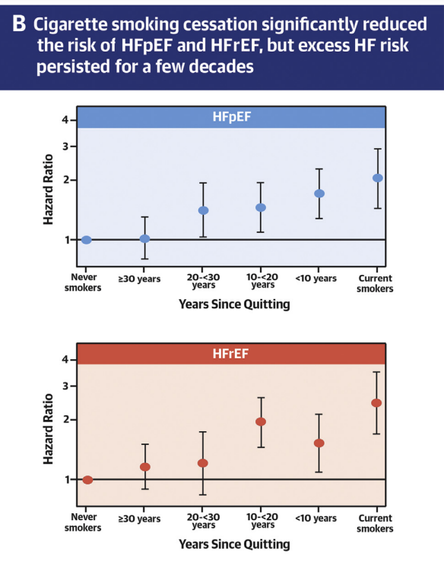

(Ding et al., 2022)

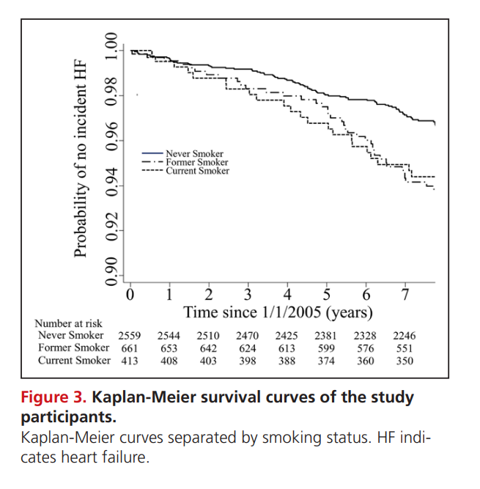

(Kamimura, D., et al., 2018)

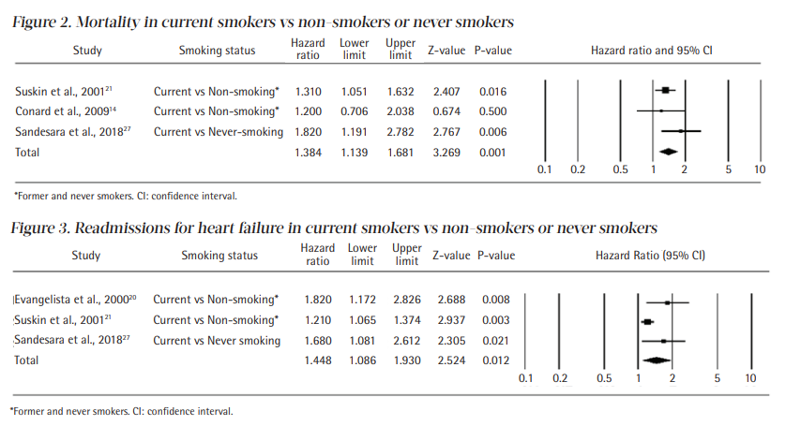

(Son & Lee, 2020)

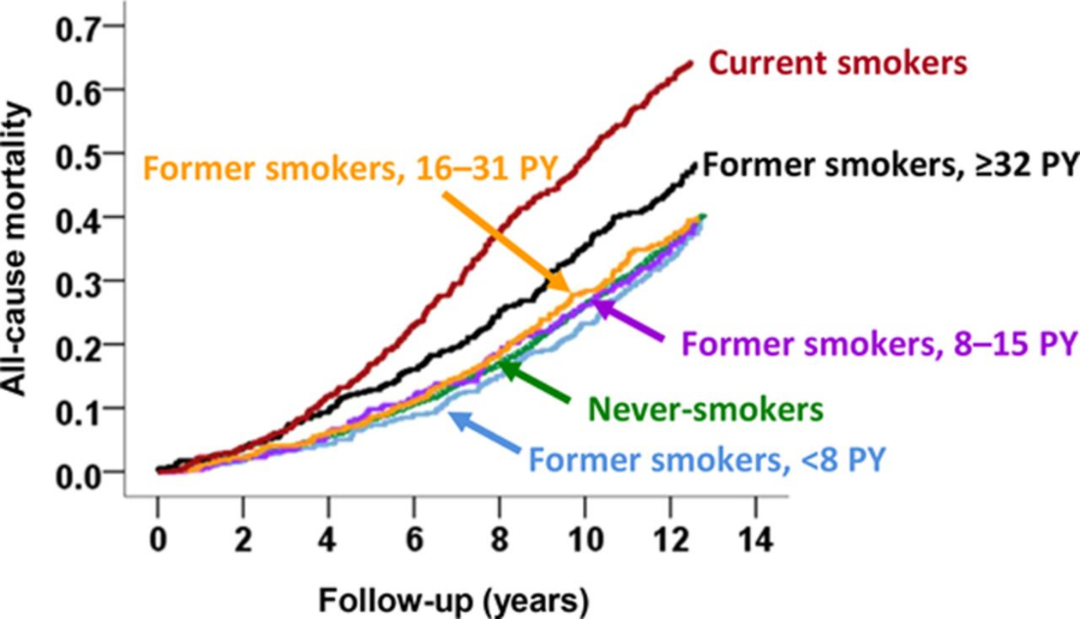

(Ahmed et al., 2015)